Lab 1 for Operating Systems

**Student: Trần Thanh Dương (SE160185)**

**Class: AI1601**

# **Install VMware Workstation (current version is 8.0.0)**

## **Requirement**

* VMware Workstation 8.x: <https://my.vmware.com/web/vmware/downloads/info/slug/datacenter_download_archives/vmware_workstation/8_0>
* Fedora OS .ISO file: <https://archives.fedoraproject.org/pub/archive/fedora/linux/releases/11/Fedora/i386/iso/>

## **Step-by-step installation**

1. Click **“Create a new Virtual Machine”**.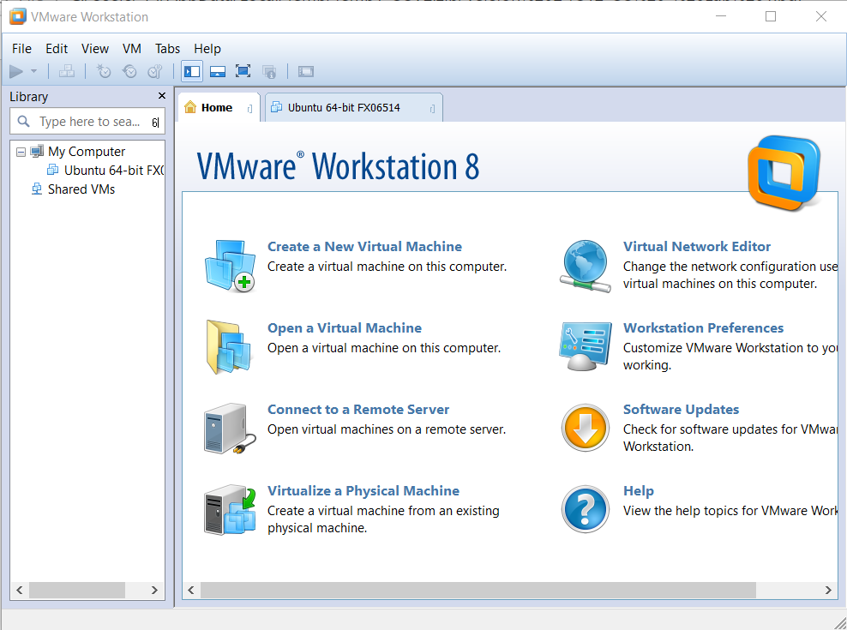
2. The **“New Virtual Machine Wizard”** window is appeared, choose **“Custom (advanced)”** and click **Next** to configure the hardware. 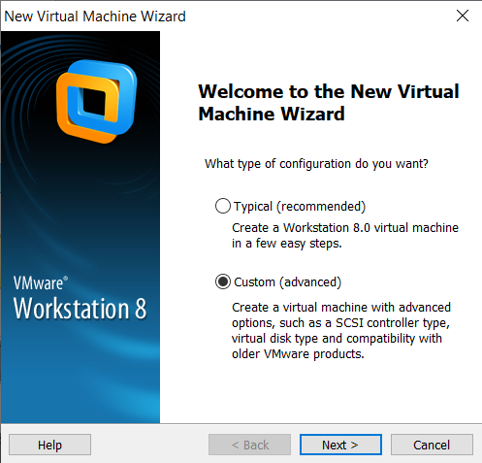
3. Choose **“Workstation x”** in *Hardware compatibility* and decide the chosen workstation that is corresponded. Click **Next**. 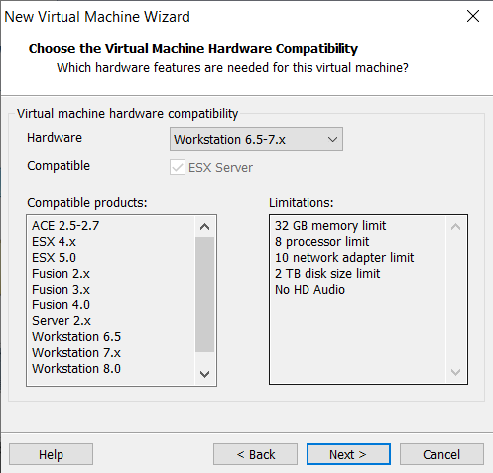
4. Choose **“I will install the operating system later”.** Click **Next**. 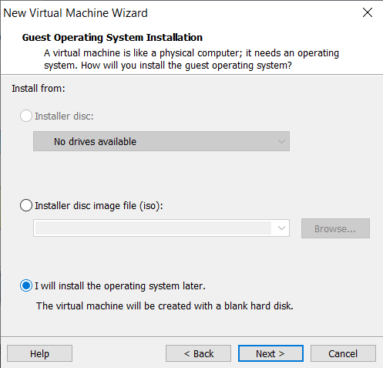
5. Choose the OS family (**e.g. Linux).** Choose the OS serial/version **(e.g. Fedora).** Click **Next**. 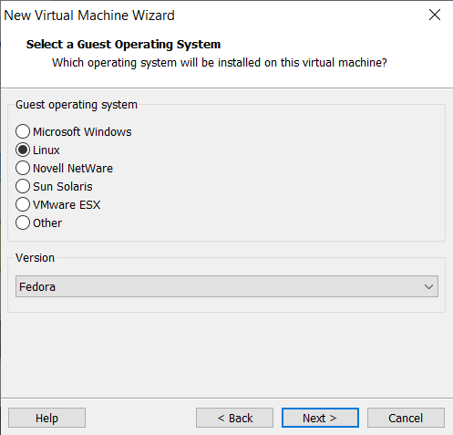
6. Type the name of virtual machine and location on hard disk to store the virtual machine. Click **Next**.

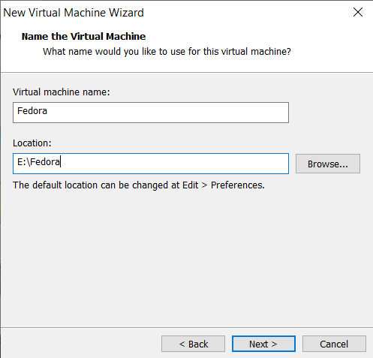

1. Configure **Processors** for your virtual machine. You can keep it as default. Click **Next**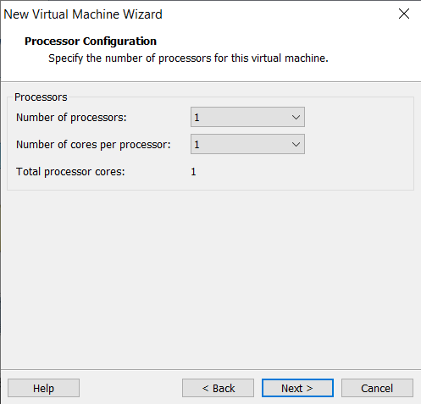
2. Type **memory size of RAM** that is used for the OS. Click **Next**. 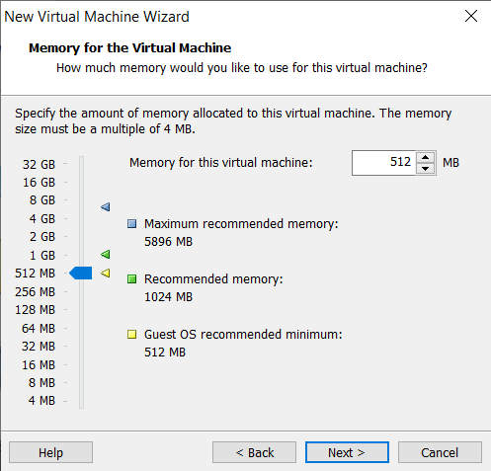
3. Choose the network connection that you want. In this case, I choose “**Use network address translation (NAT)”**. Click **Next**. 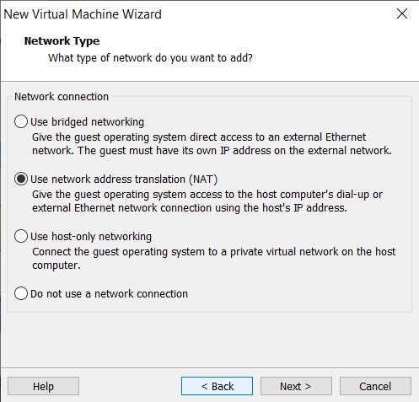
4. Click **Next** (should be used the recommendation of software). 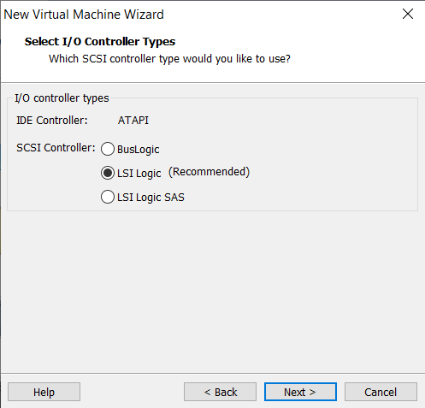
5. Choose **“Create a new virtual disk”**. Click **Next**. 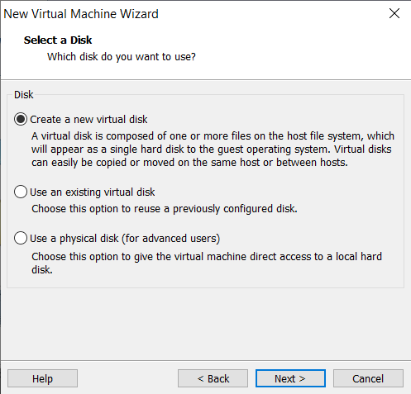
6. Click **Next** (should be used the recommendation of software). 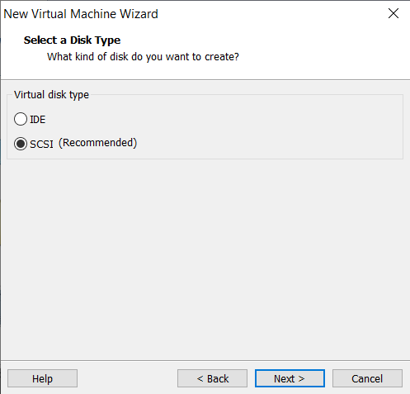
7. Click **Next**.

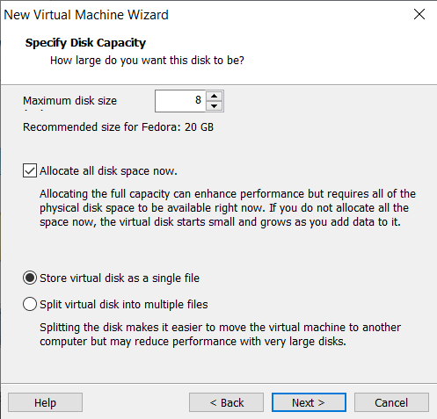

1. Click **Next**.

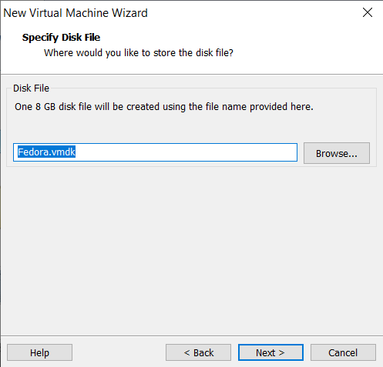

1. Click **Next**.

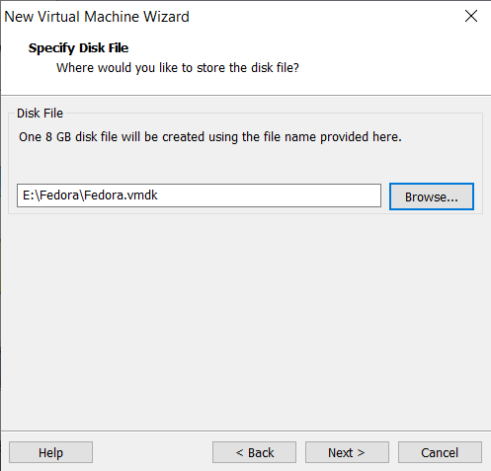

1. Click **Finish** to complete the installation of the new machine. 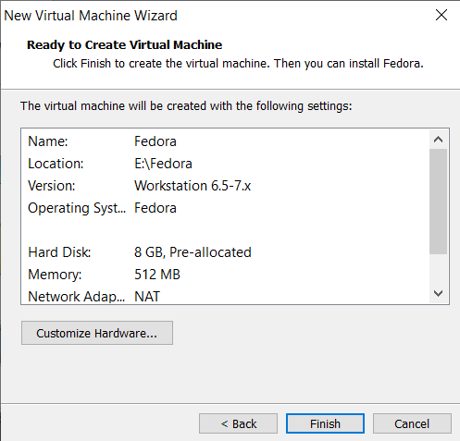
2. The window as below is shown. 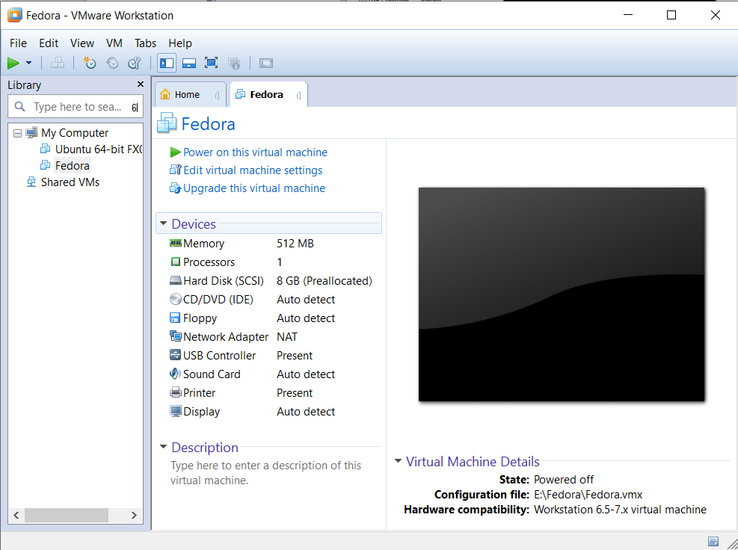

**Setup the Fedora OS on VMWare**

1. Creating the Virtual Machine disk for setup Fedora 11 OS (Recommended: HDD >= 8GB, RAM >= 512MB, the Network connection should be NAT).

Click **“Edit virtual machine settings”**.



1. Choose **Hardware tab/ Choose CD/DVD (IDE).** Choose **“Use ISO image file”** and browse to the ISO file. Click **OK**.

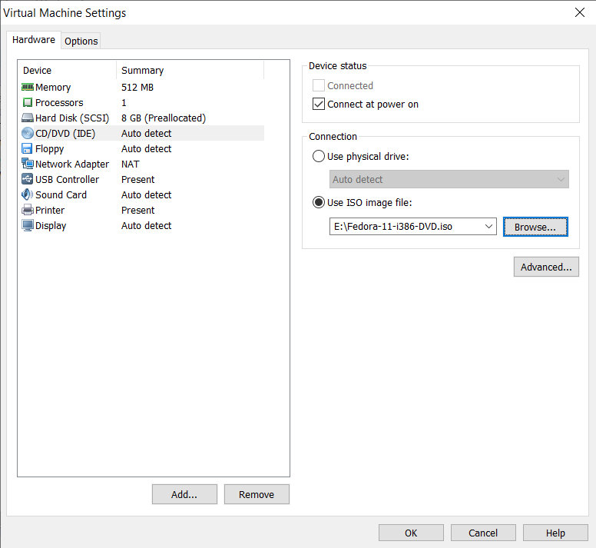

1. Click the **“Power on this virtual machine”.**



1. The virtual machine is started, then you can see the screen. Use your arrow keys to choose **“Install or upgrade an existing system”**, then press **Enter**.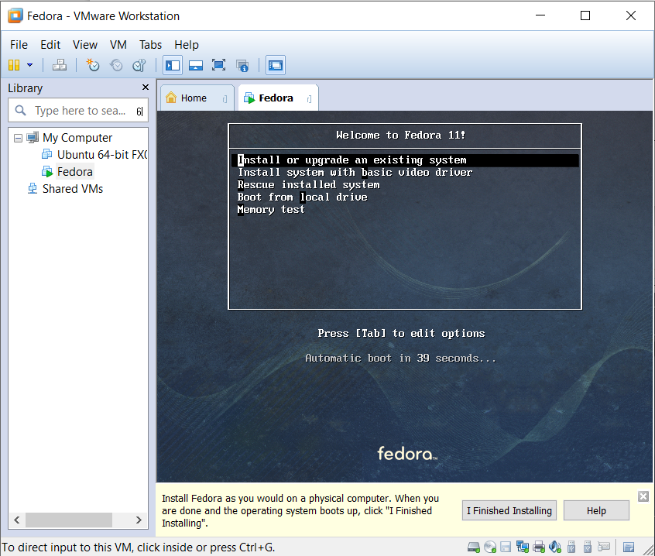
2. Choose **Skip**.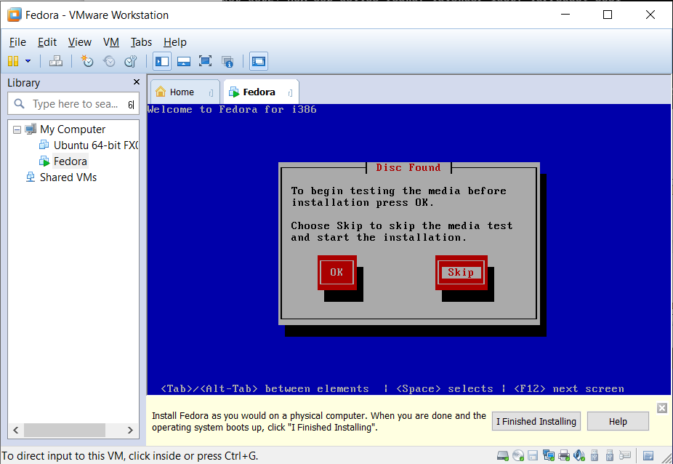
3. Click **Next**.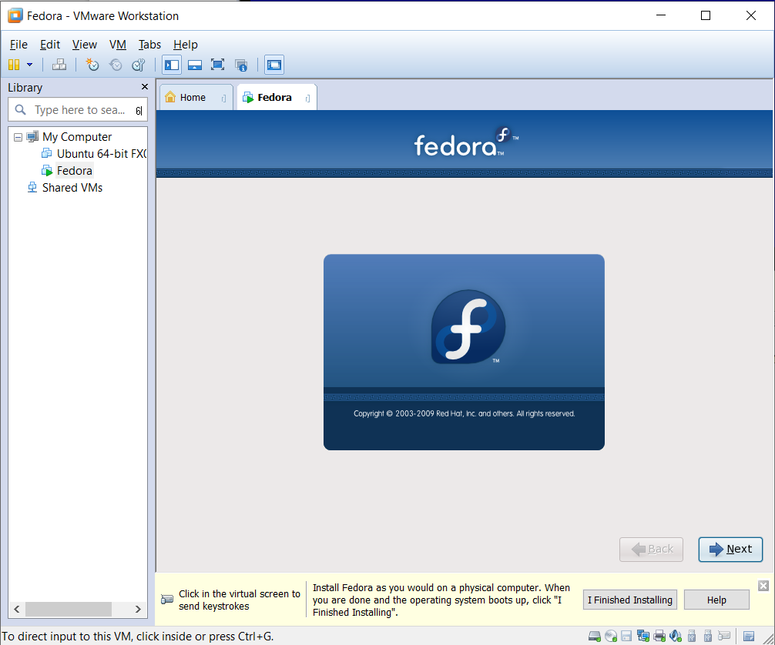
4. Click **Next**.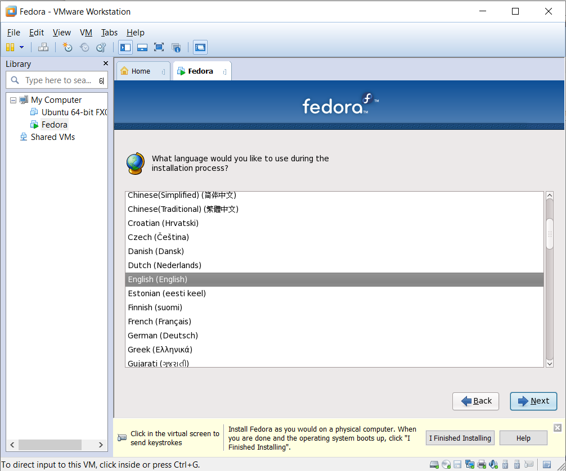
5. Choose Language. Click **Next**.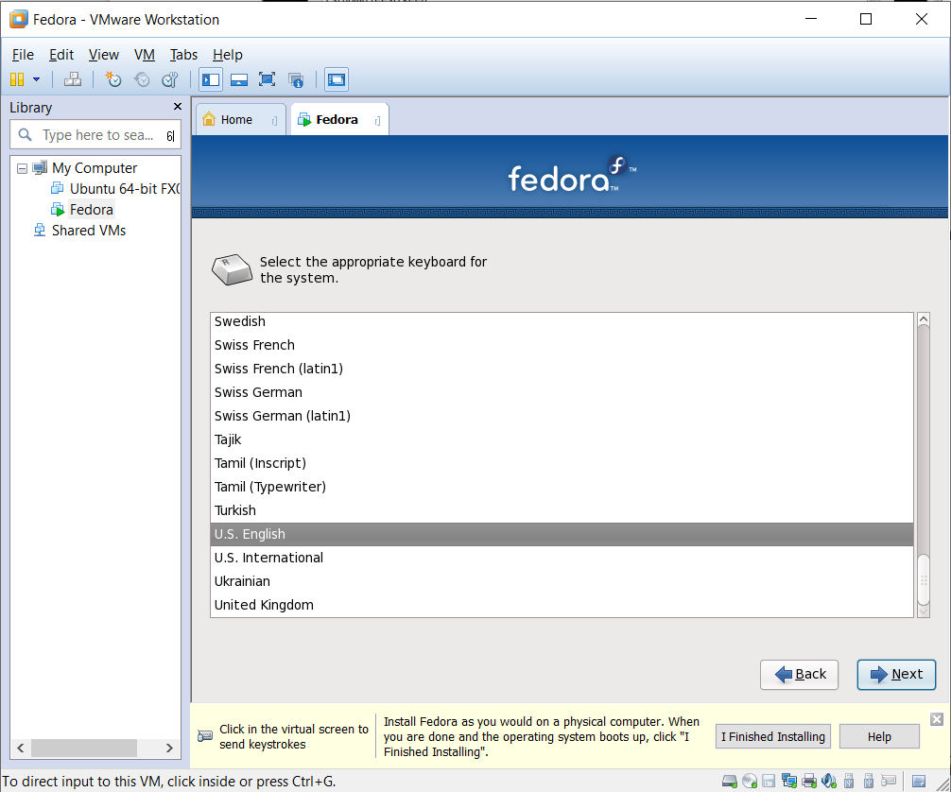
6. Click **“Re-initialize drive”** to reset the default partition following the OS’s requirement.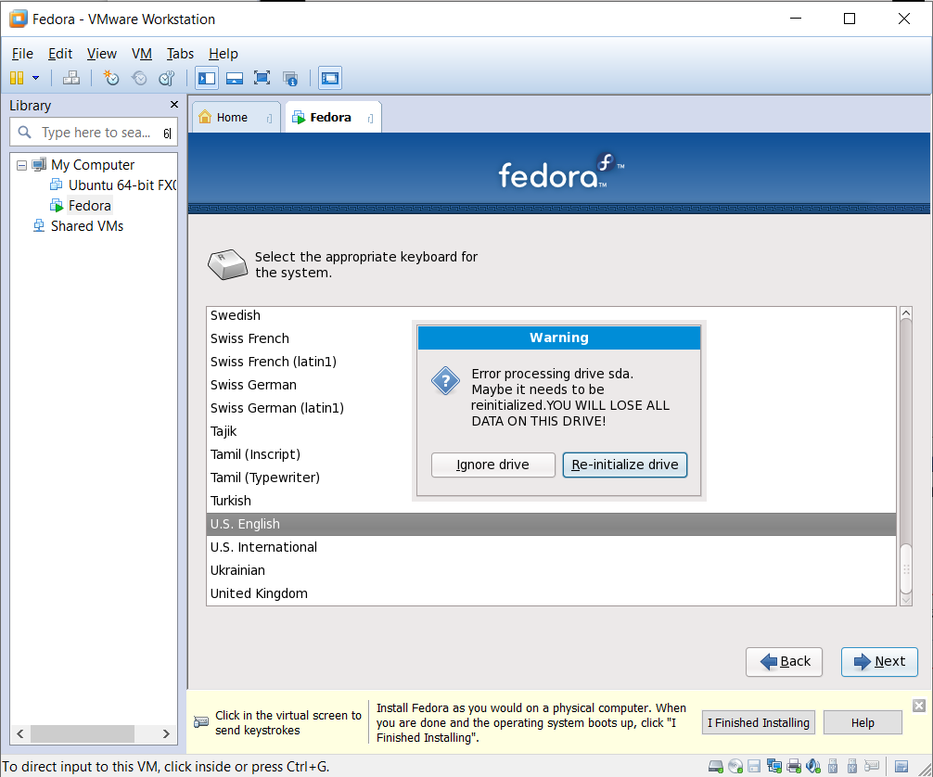
7. Type the computer name.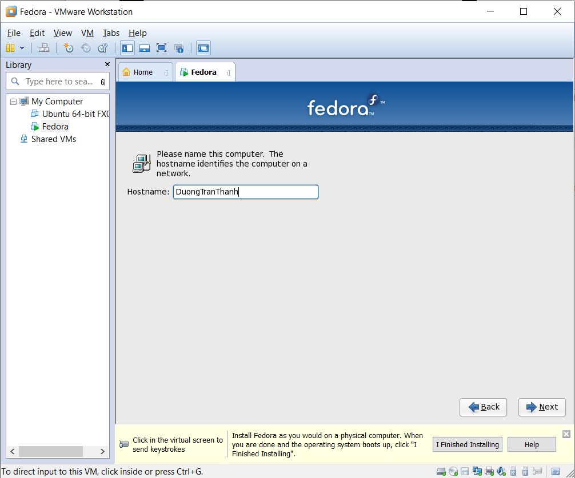
8. Choose **Asia/Ho Chi Minh**. Click **Next**.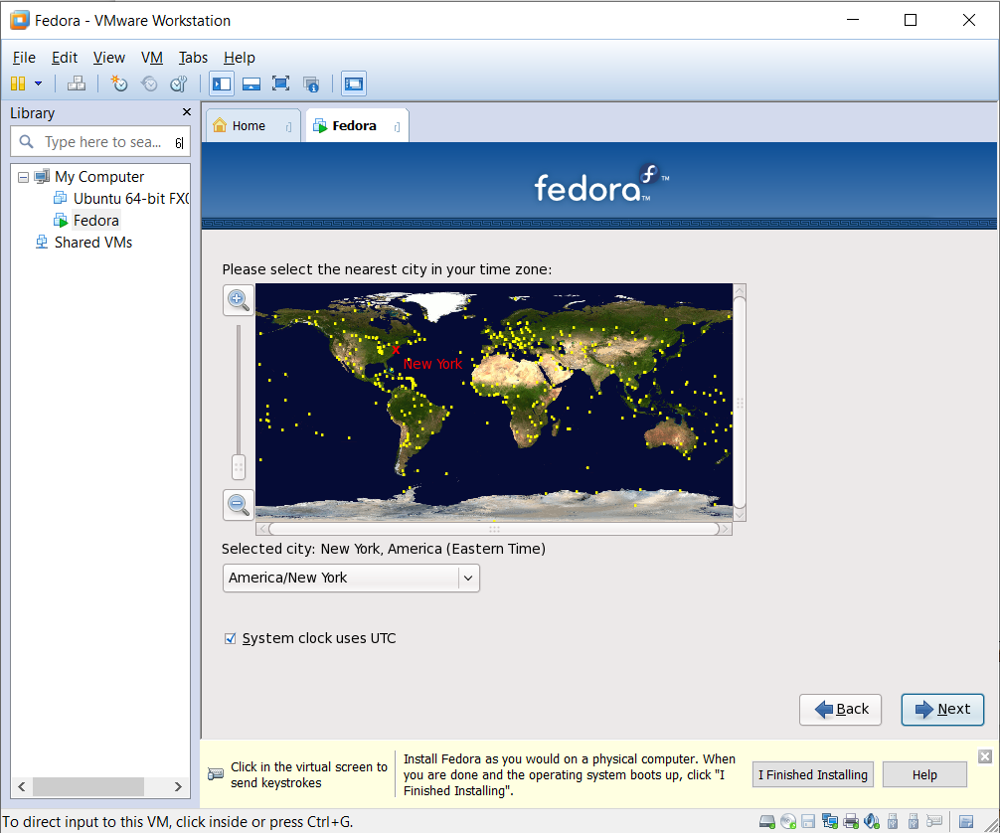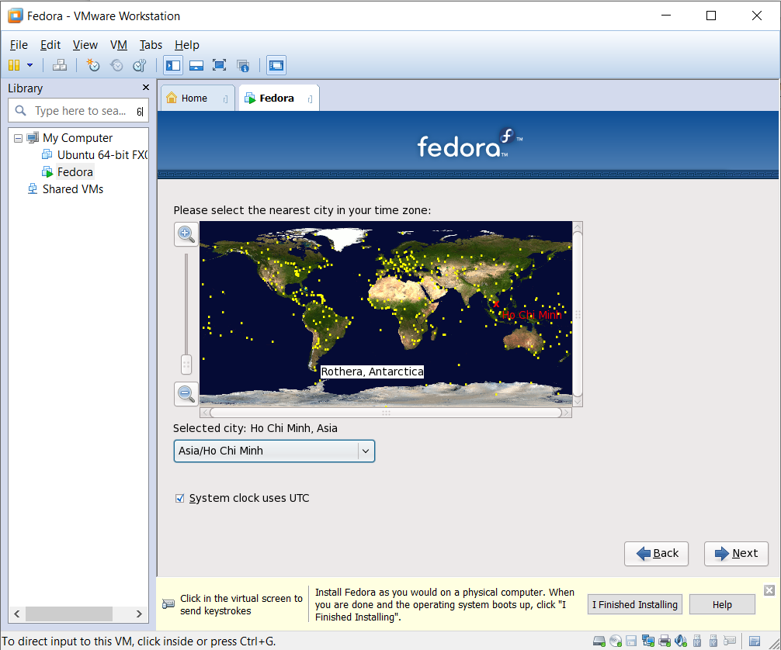
9. Type root password and confirm. Click **Next**.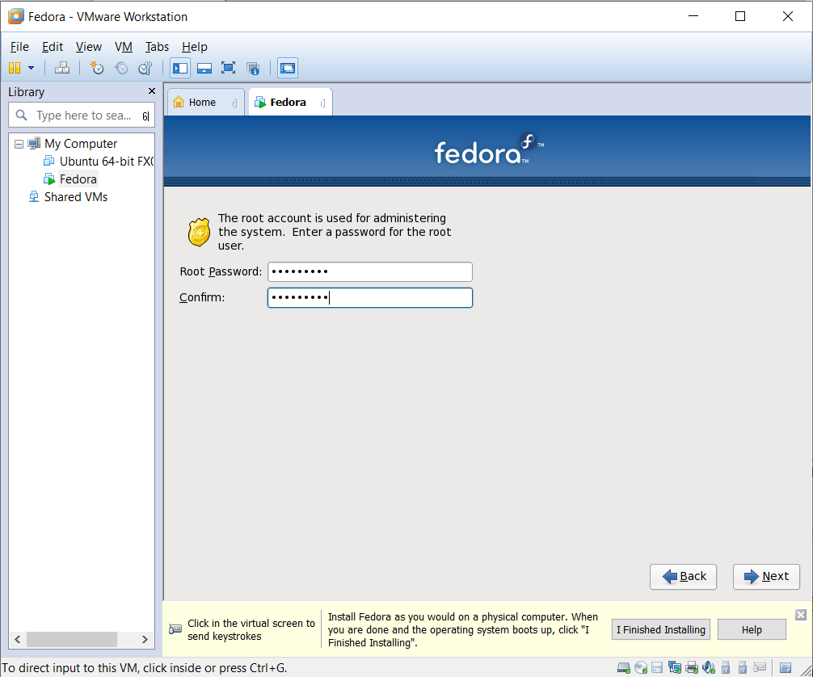
10. Choose **“Replace existing Linux System”.** Check **“Review and modify partitioning layout”.**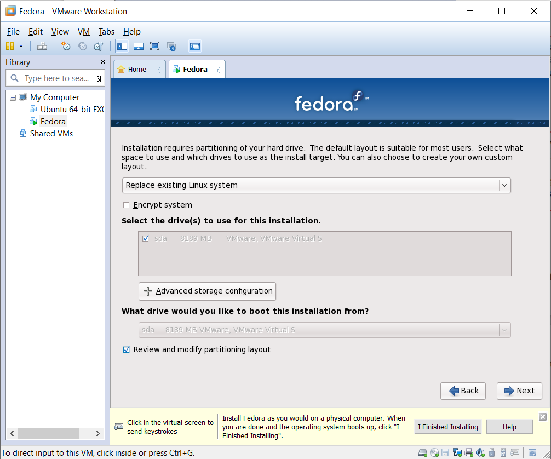
11. Choose **Reset** to delete the available partition. Click **Yes** if the warning is appeared.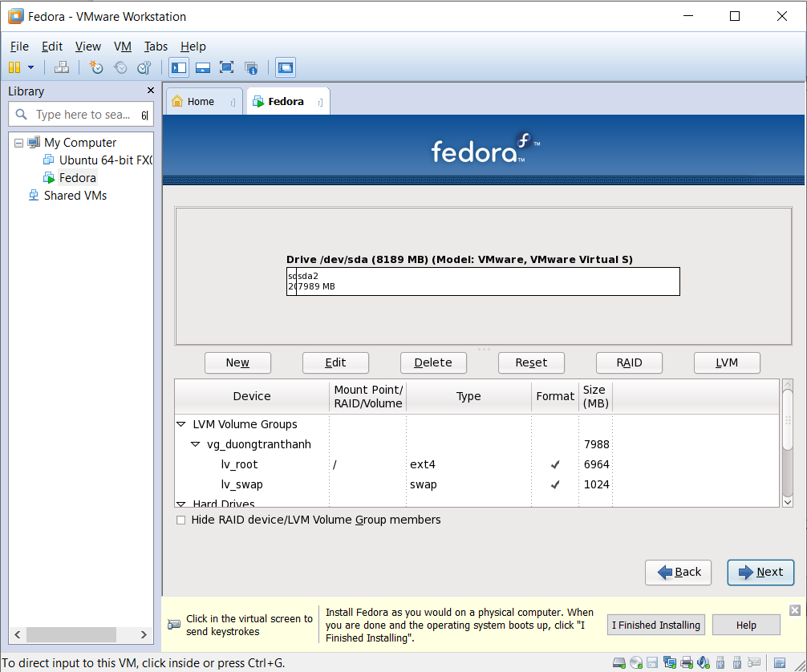
12. Click New to create new partition.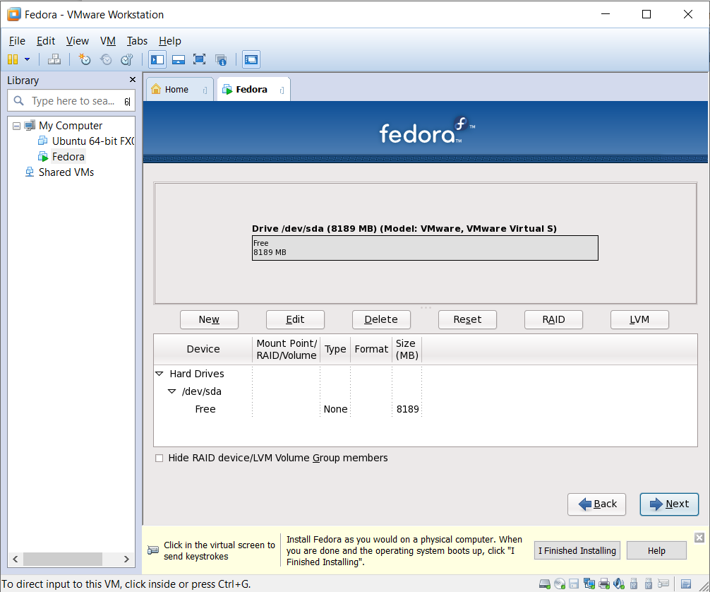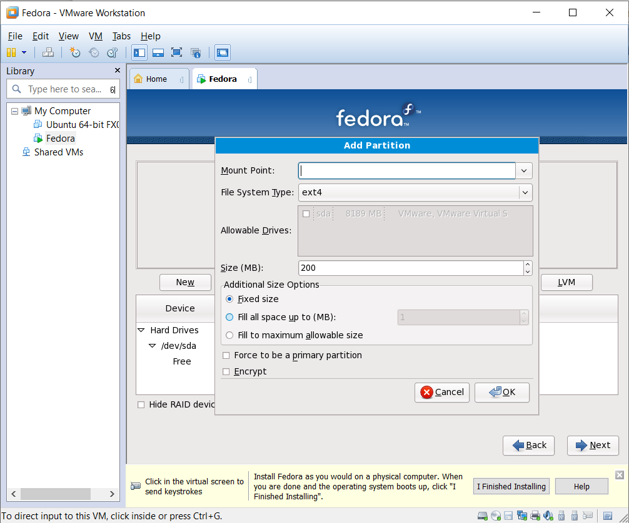
13. Click **OK**.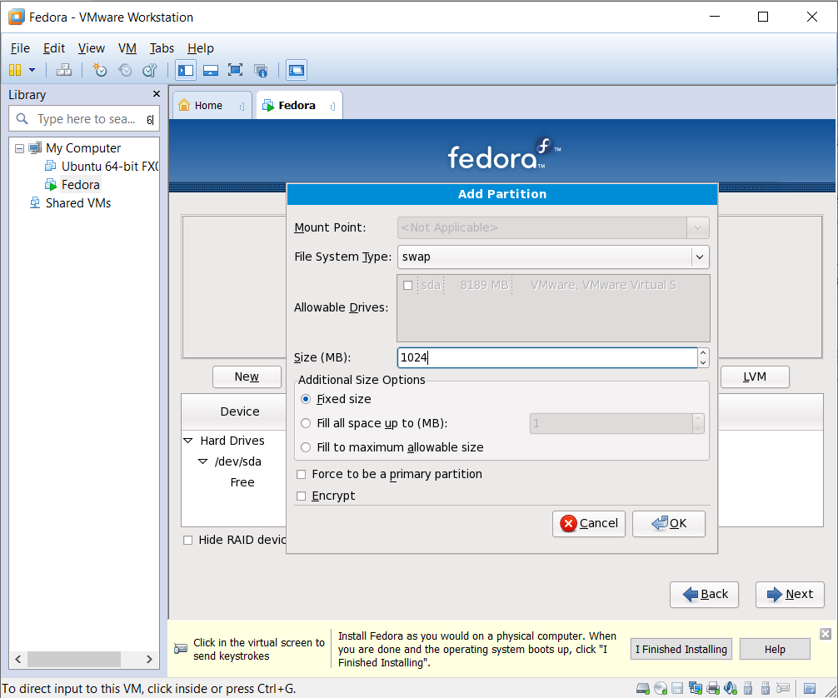
14. Click **New** again and configure as image below. Click **OK**.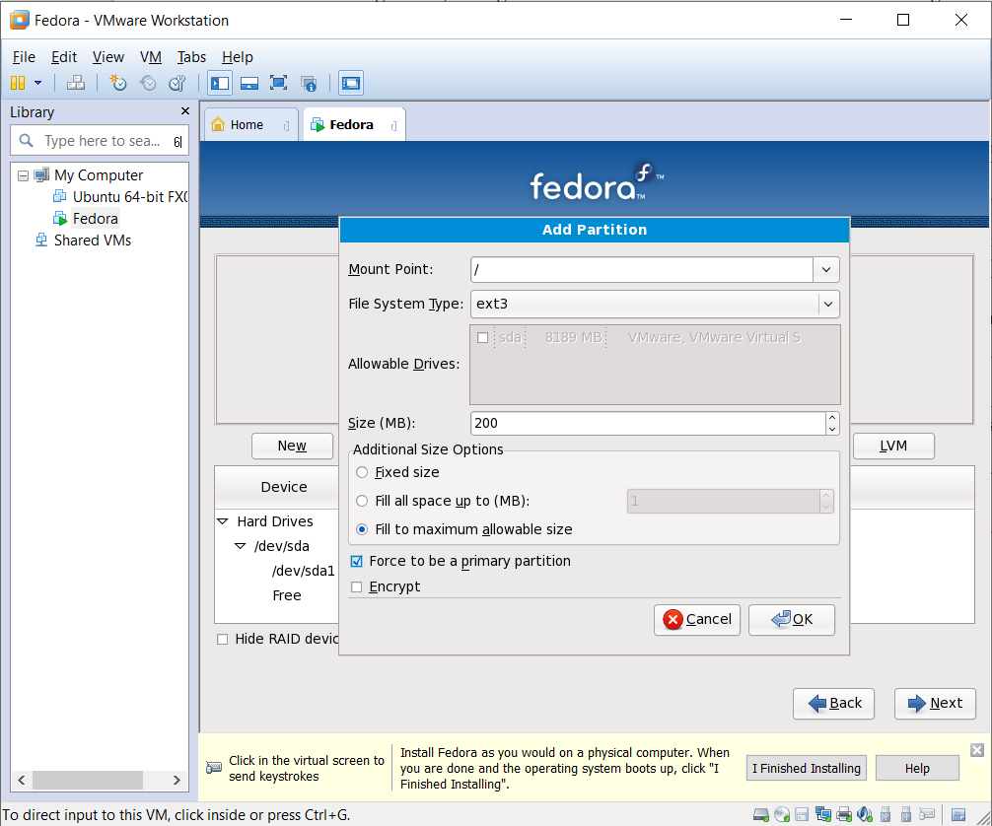
15. Click **Next**.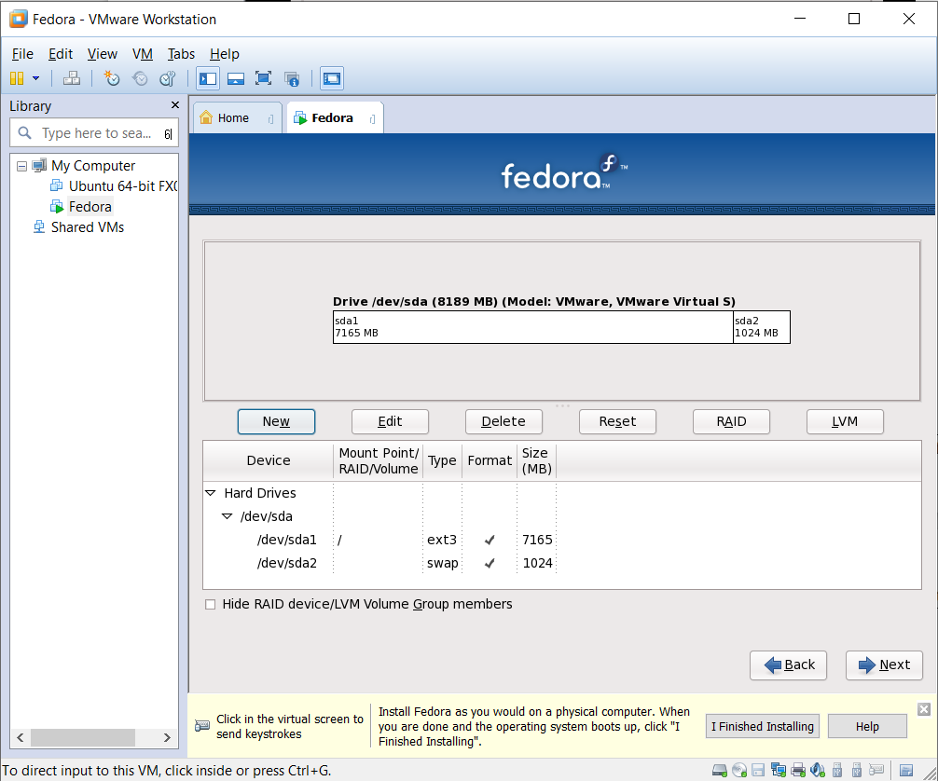
16. Choose **“Write changes to disk”.**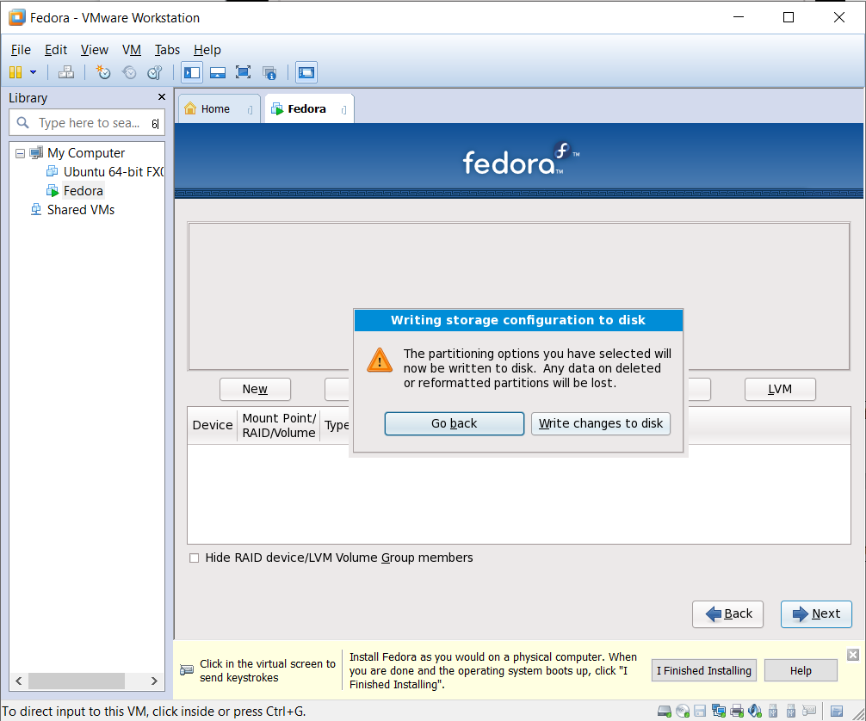
17. Click **Next**.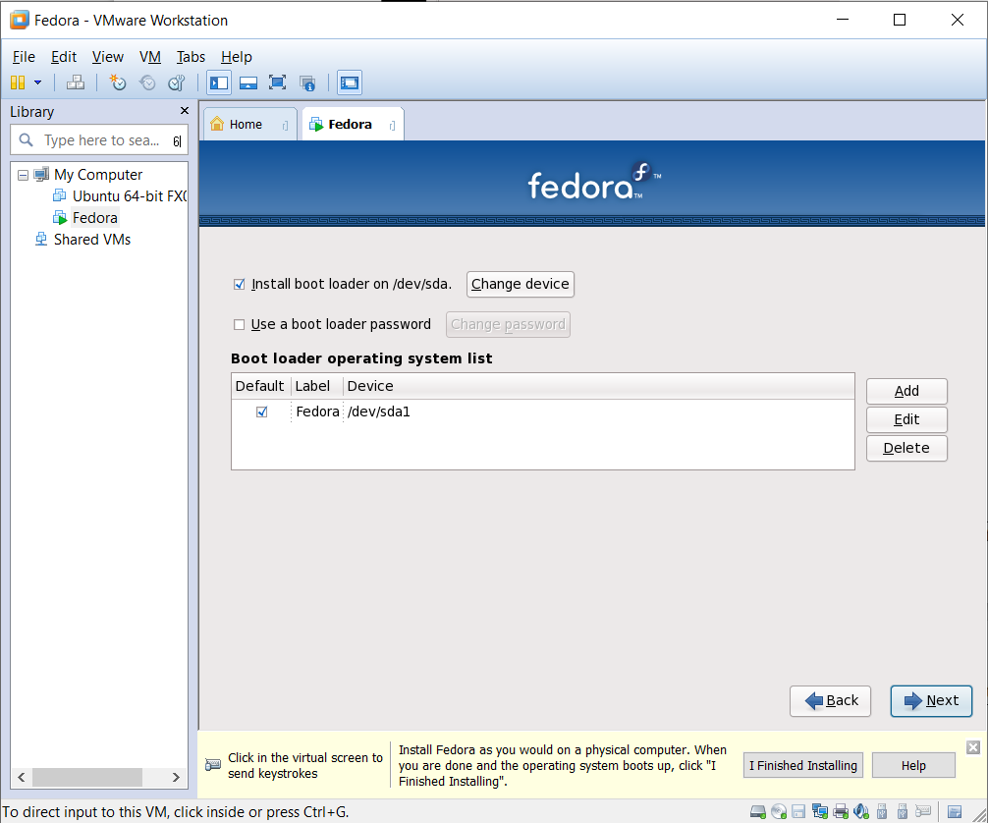
18. Choose the software/component installed. Click **Next**.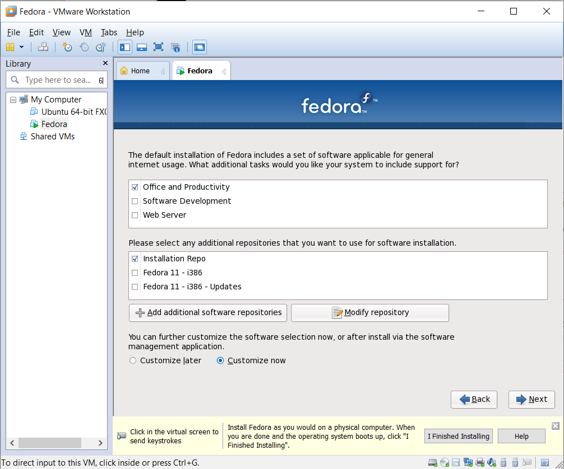
19. Choose each of component, then choose software you want to install.

Notes: must choose the package **mc\*\*\*** in **System Tools**.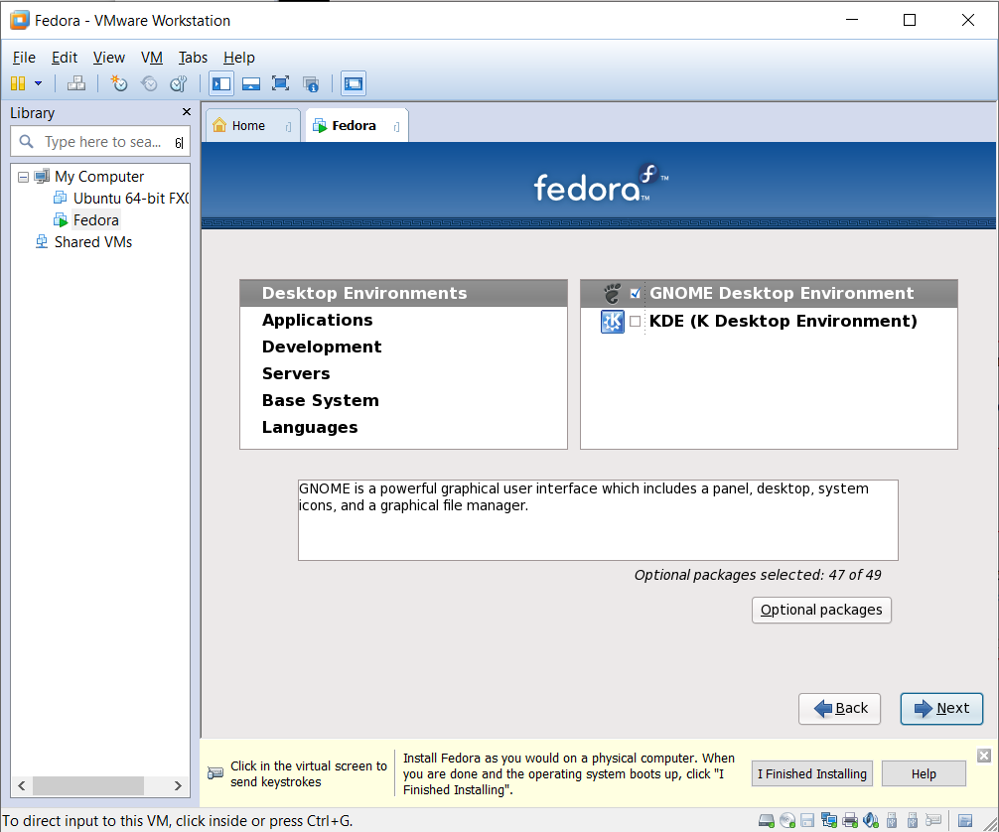

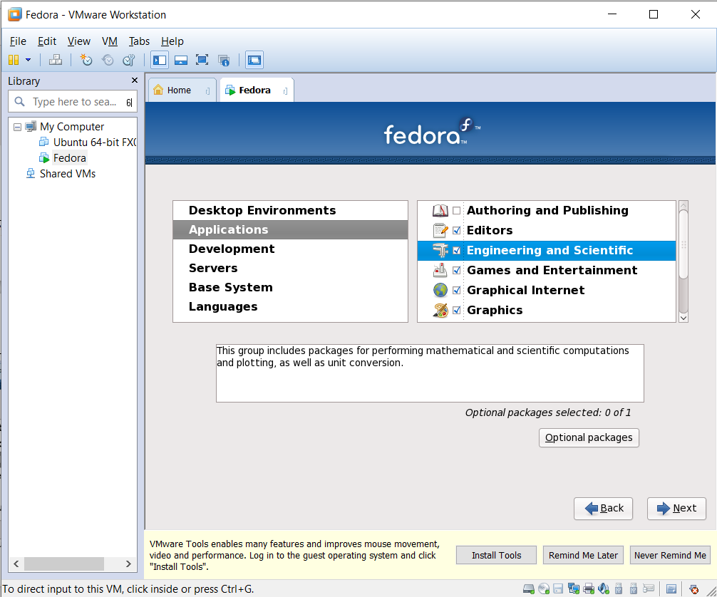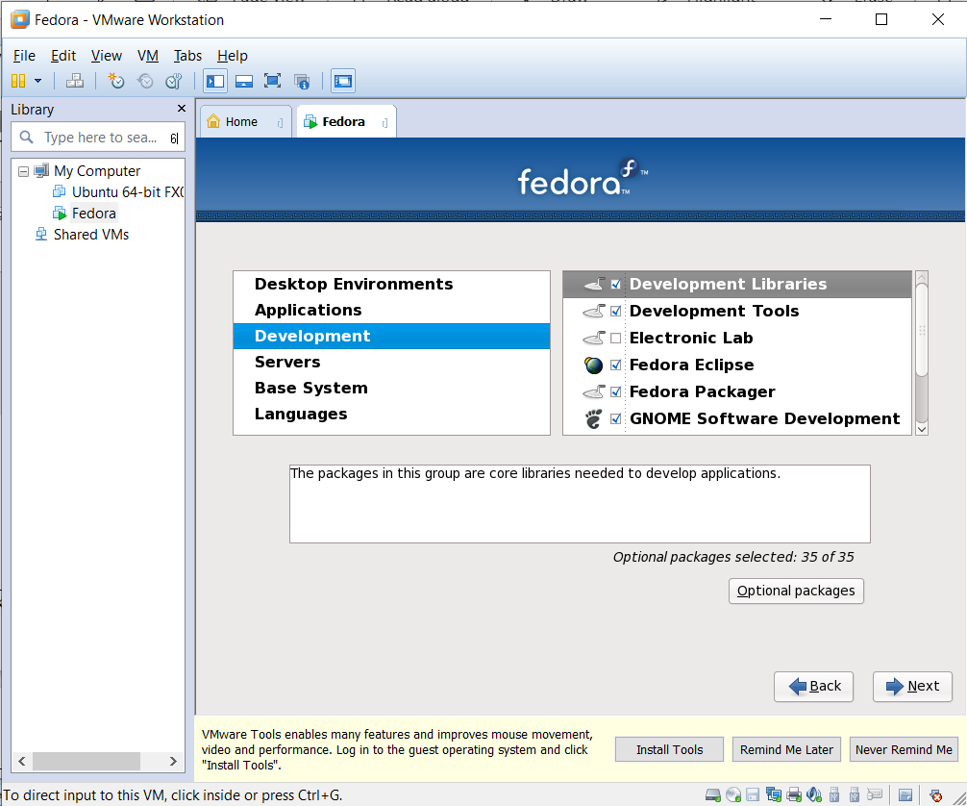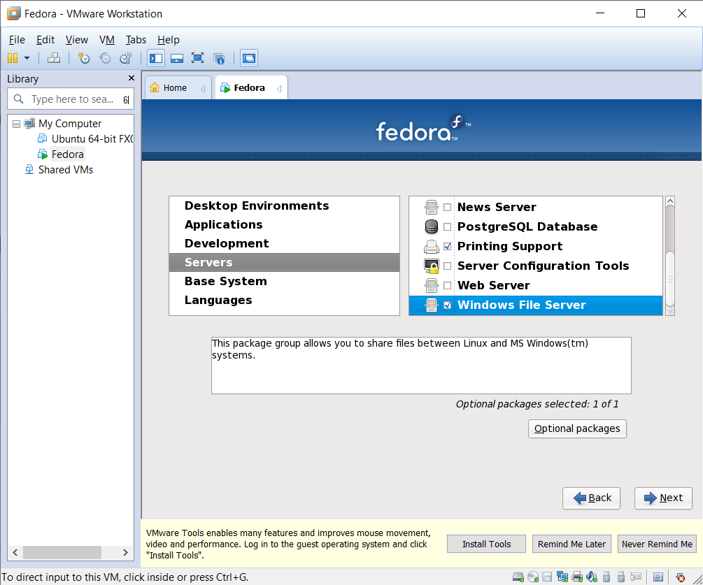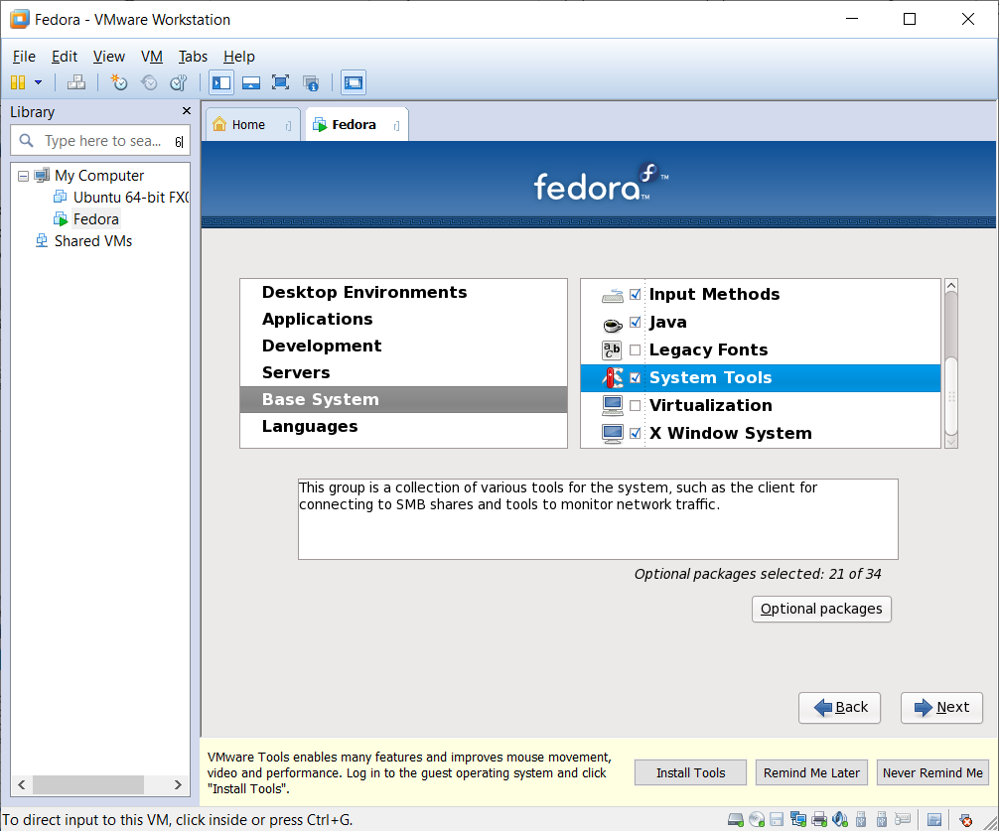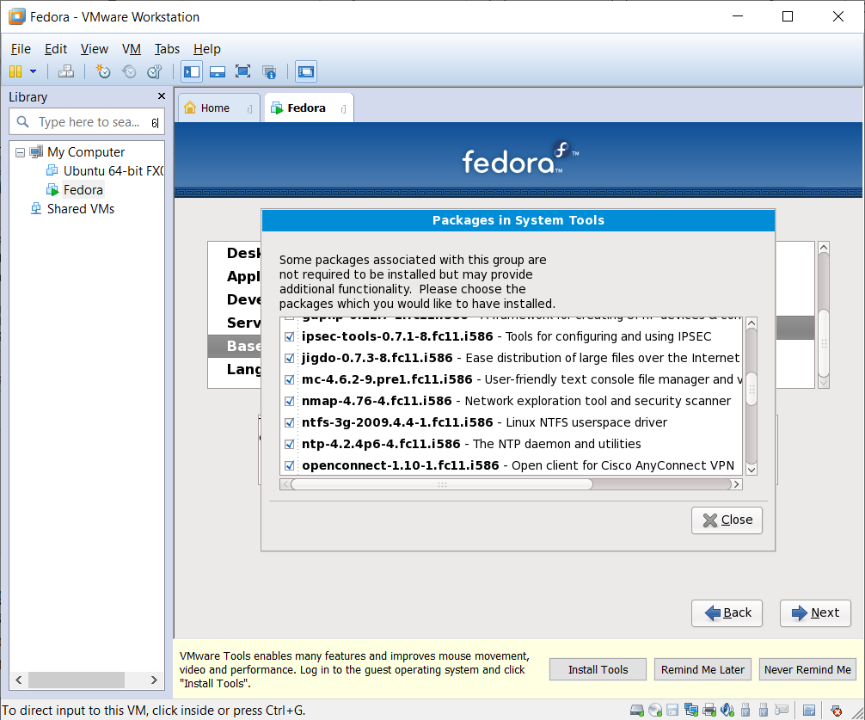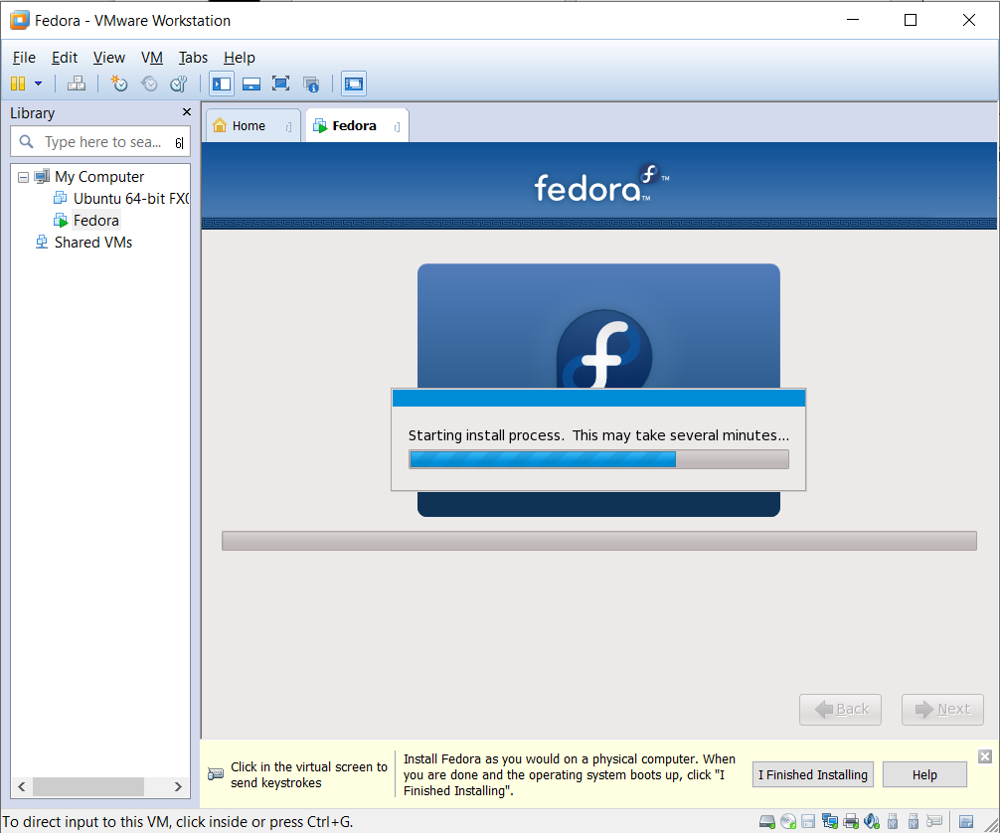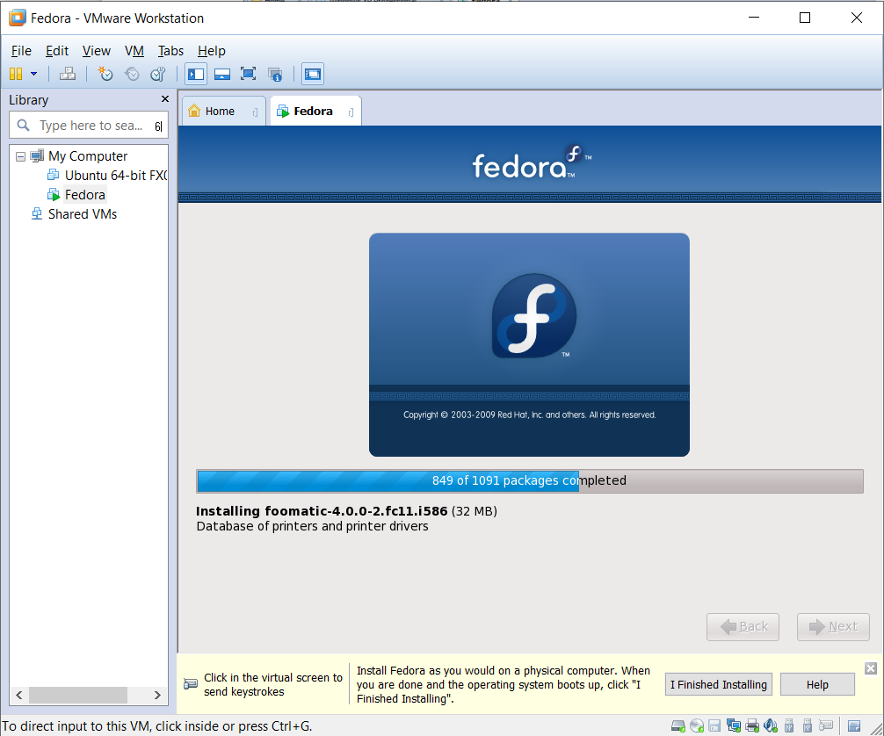

1. Click **Reboot** to finish.

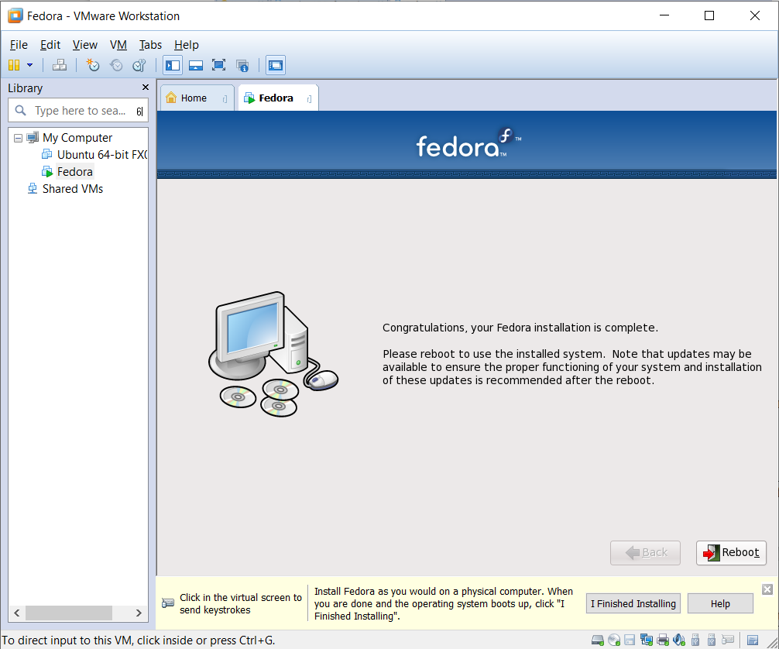

**How to use the Fedora OS**

1. Click **Forward**.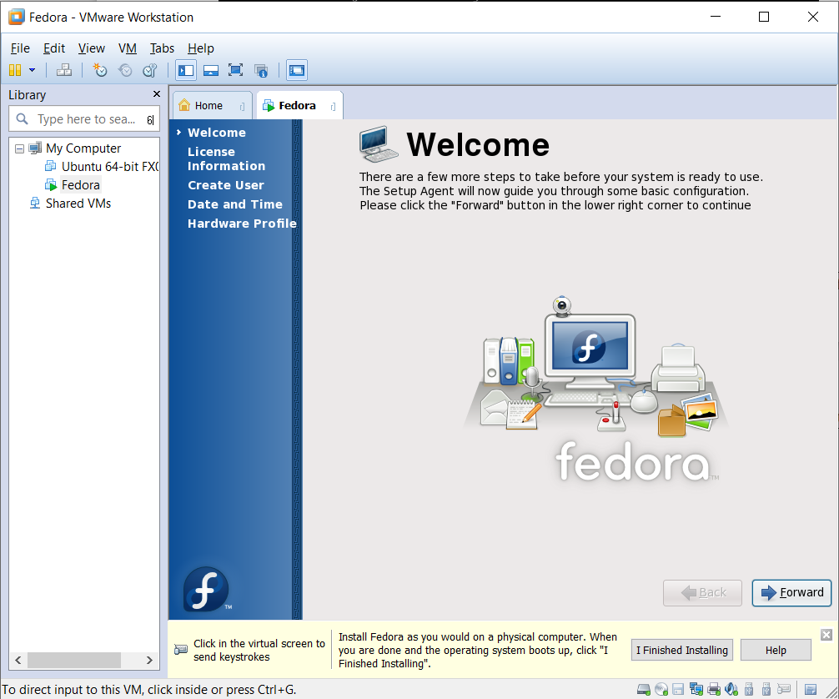
2. Click **Forward** again.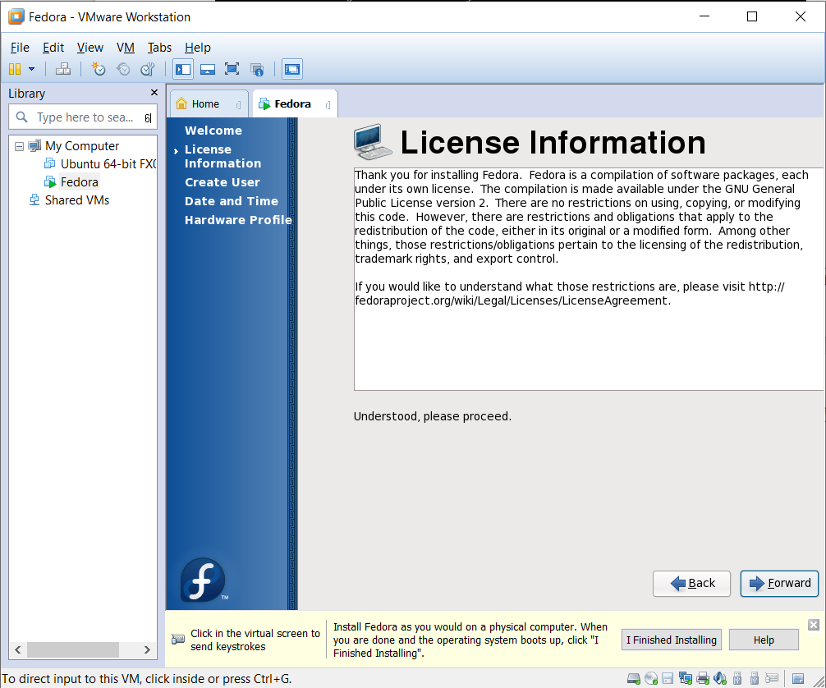
3. Fill Username, Full Name, Password, Confirm Password. Then click **Forward**.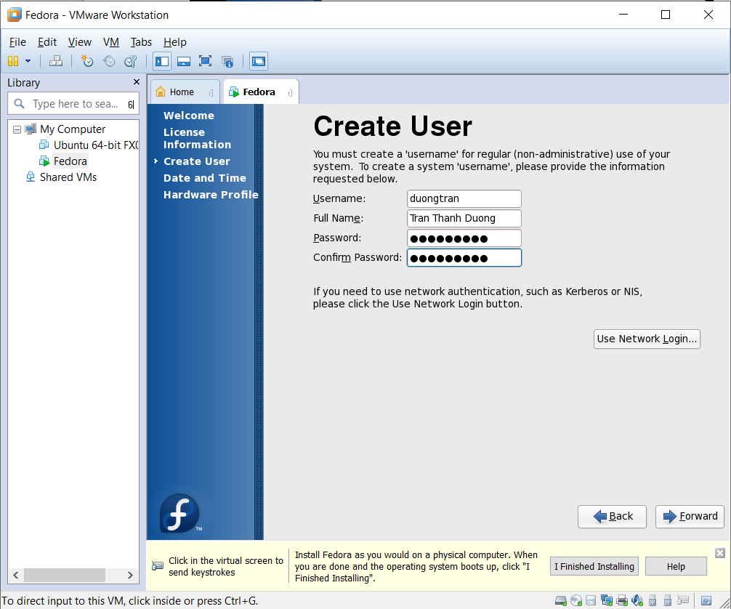
4. Choose the correctly time. Then, click **Forward**.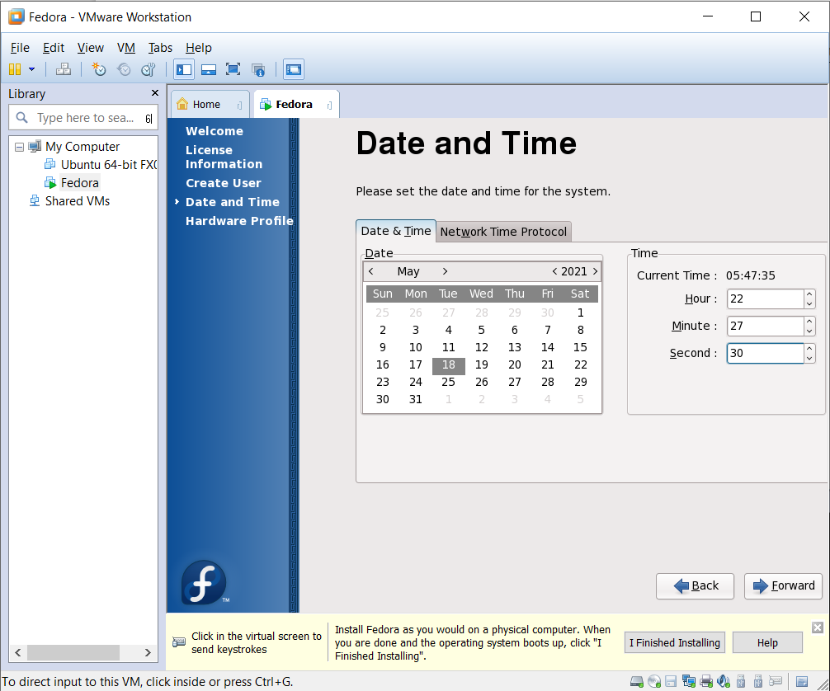
5. Click **Finish**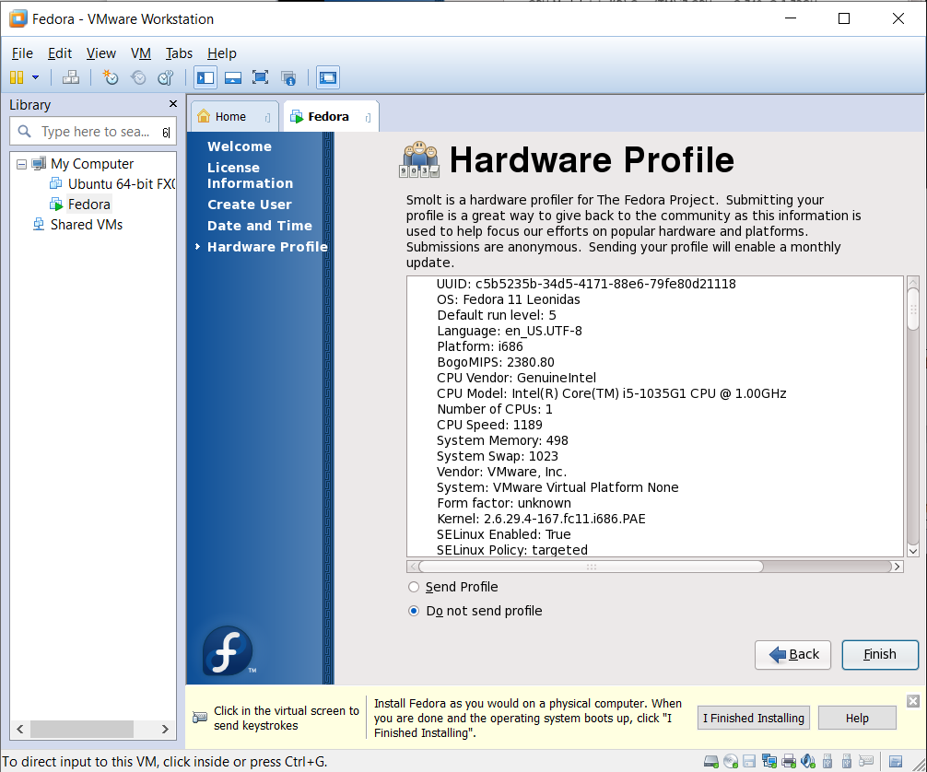

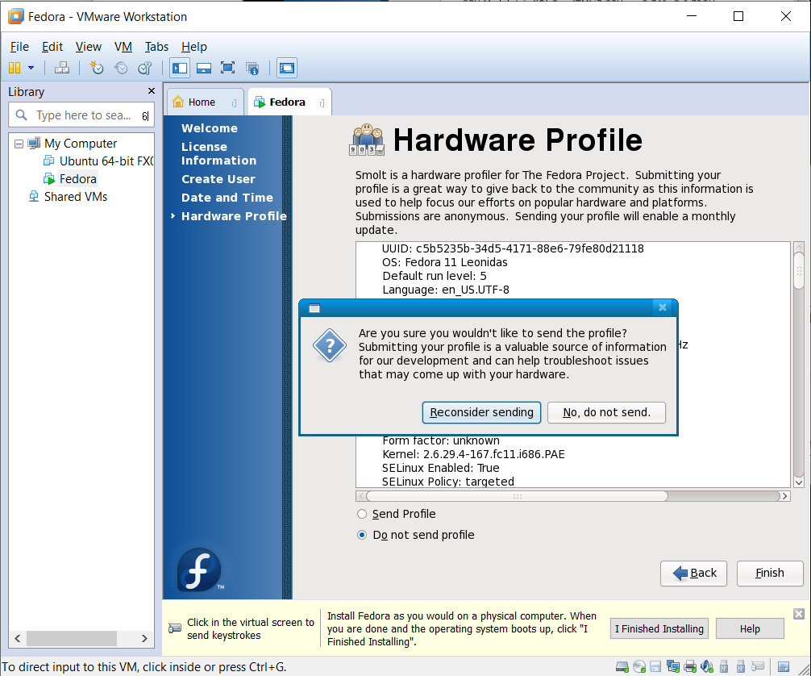

1. Click the account, then type the password.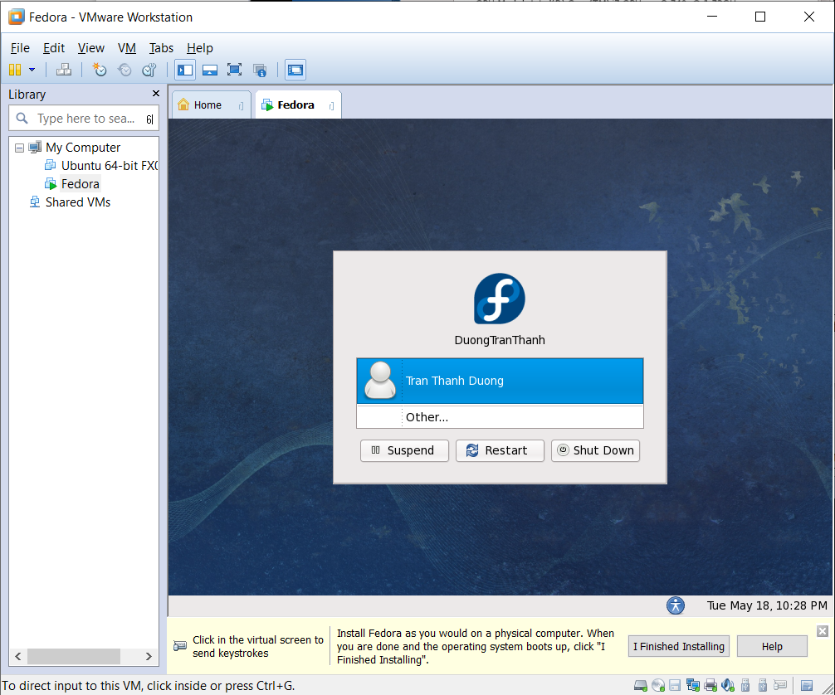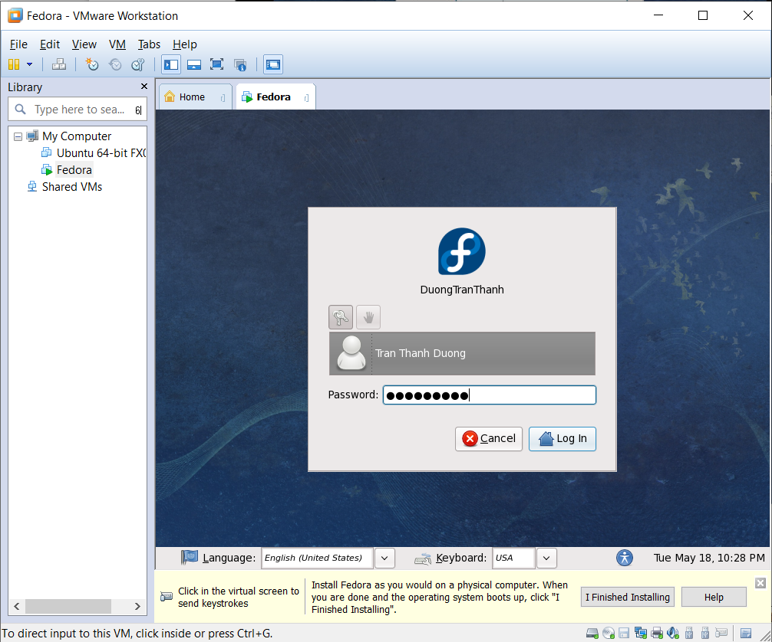
2. Try using it.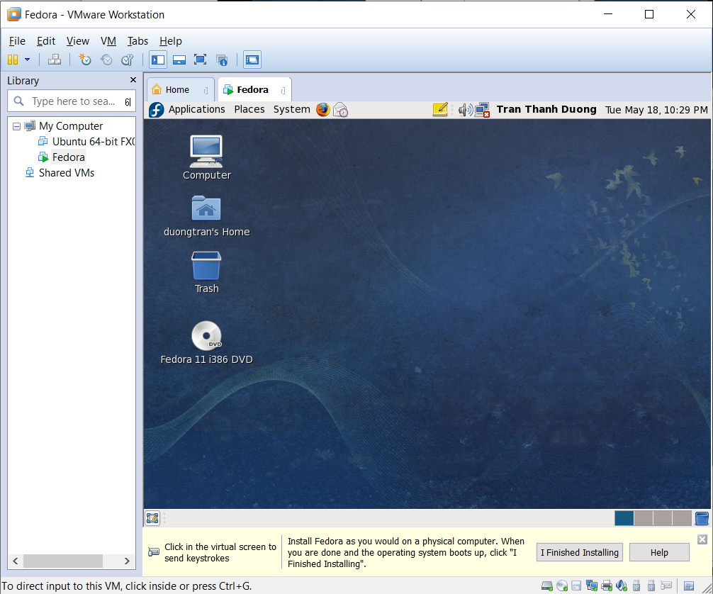

**Learning to use the mc, terminal in Fedora OS, and setting up the addition program, networking for OS**

**Connect to real machine to access the shared hark disk**

1. In Windows:

* Set password using ***Administrative Tools/ Computer Management/ Choose Local Users and Groups/ Choose Users/ Right click on Administrator, then choose Set Password ...***
* Create the shared disk or folder ***(right click on disk or folder/ Click Properties/ Choose the Sharing tab/ Click Advanced Sharing Button/ check the “Share this folder” checkbox, click OK, and click Apply/ OK***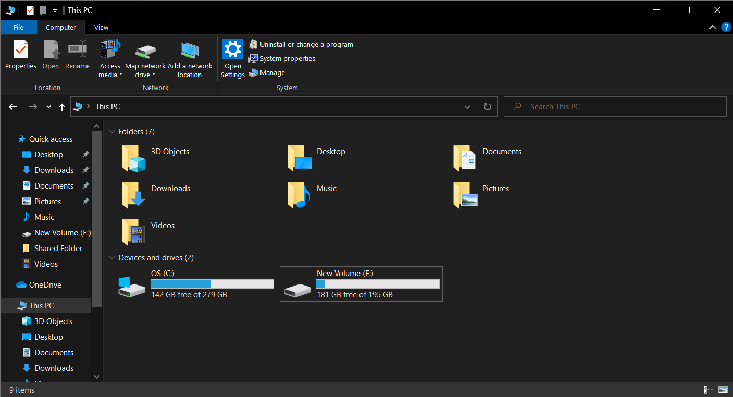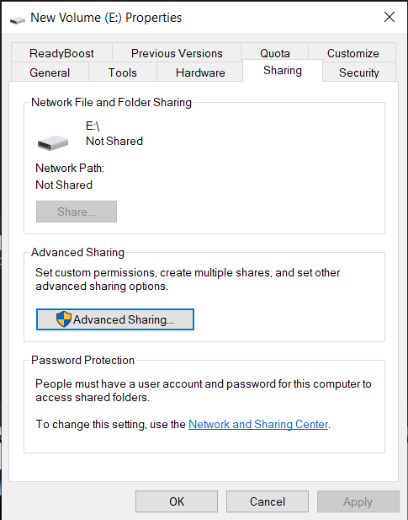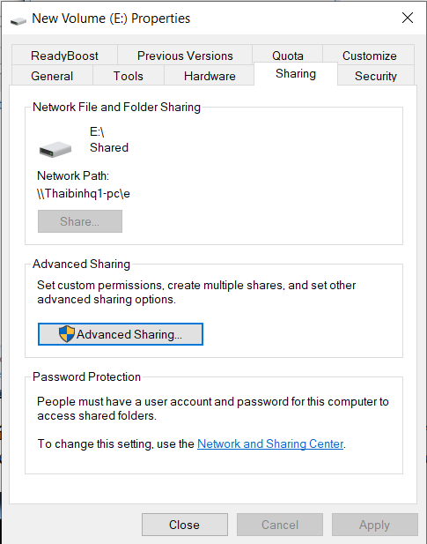

1. Get the IP config of the VMnet1 that is used to type the “Server” item of **“Connect to Server”** in Fedora (using cmd, then type **ipconfig /all**)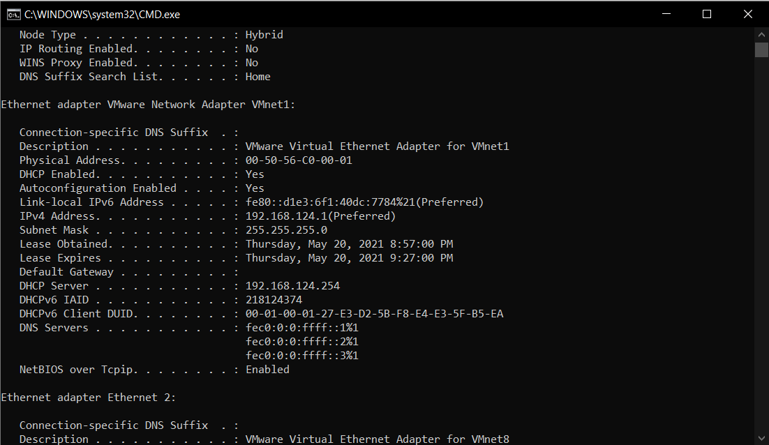
2. In Fedora, access the shared disk or folder as following:

* Connect or active the connection. 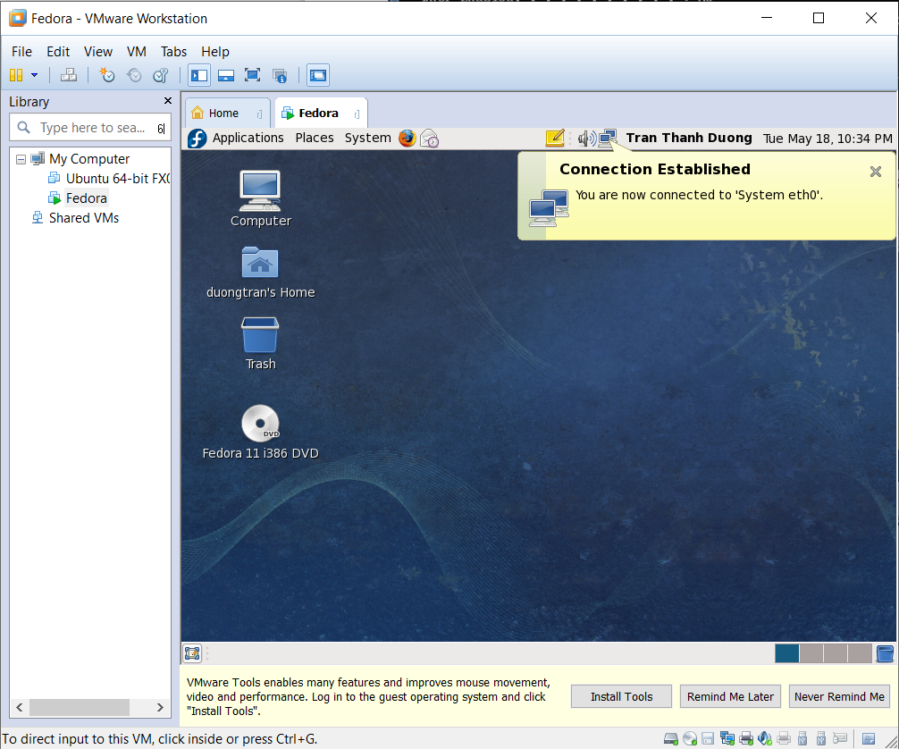
* Choose Places, click **“Connect to Server”** 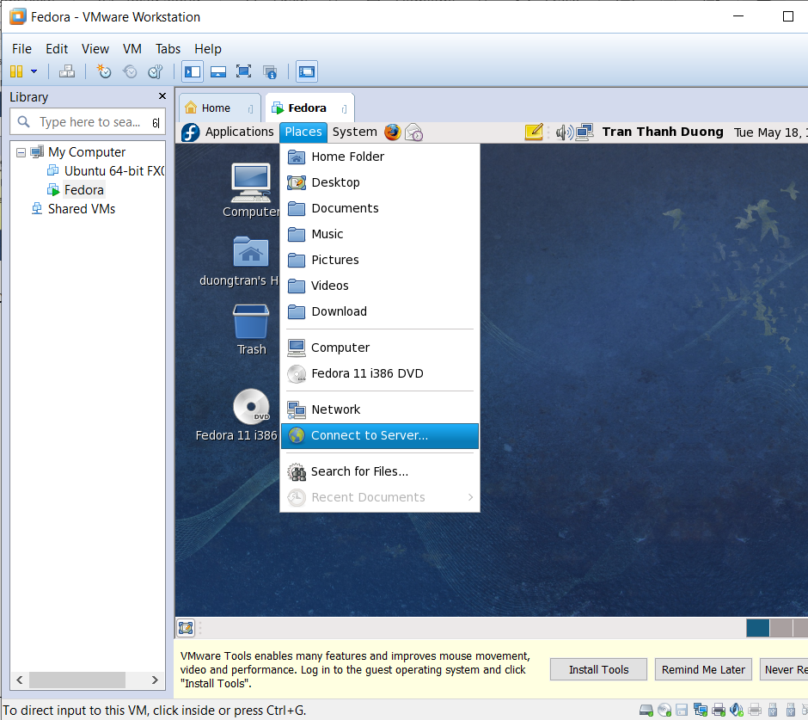
* Click **Connect**. 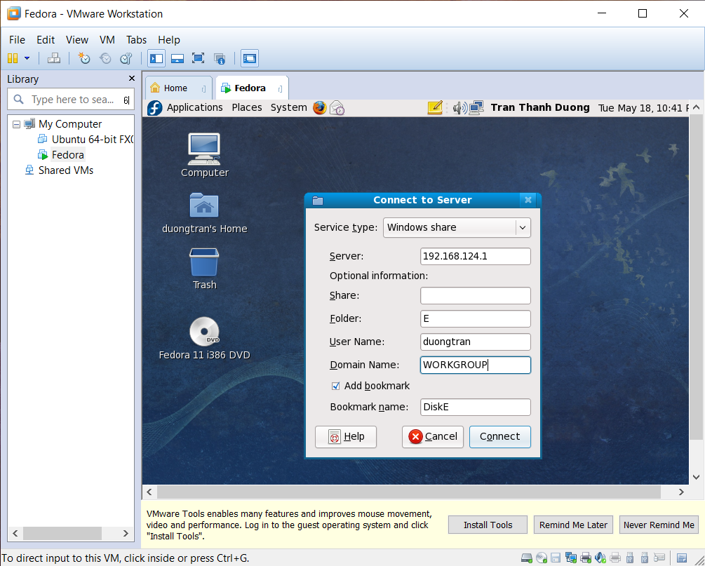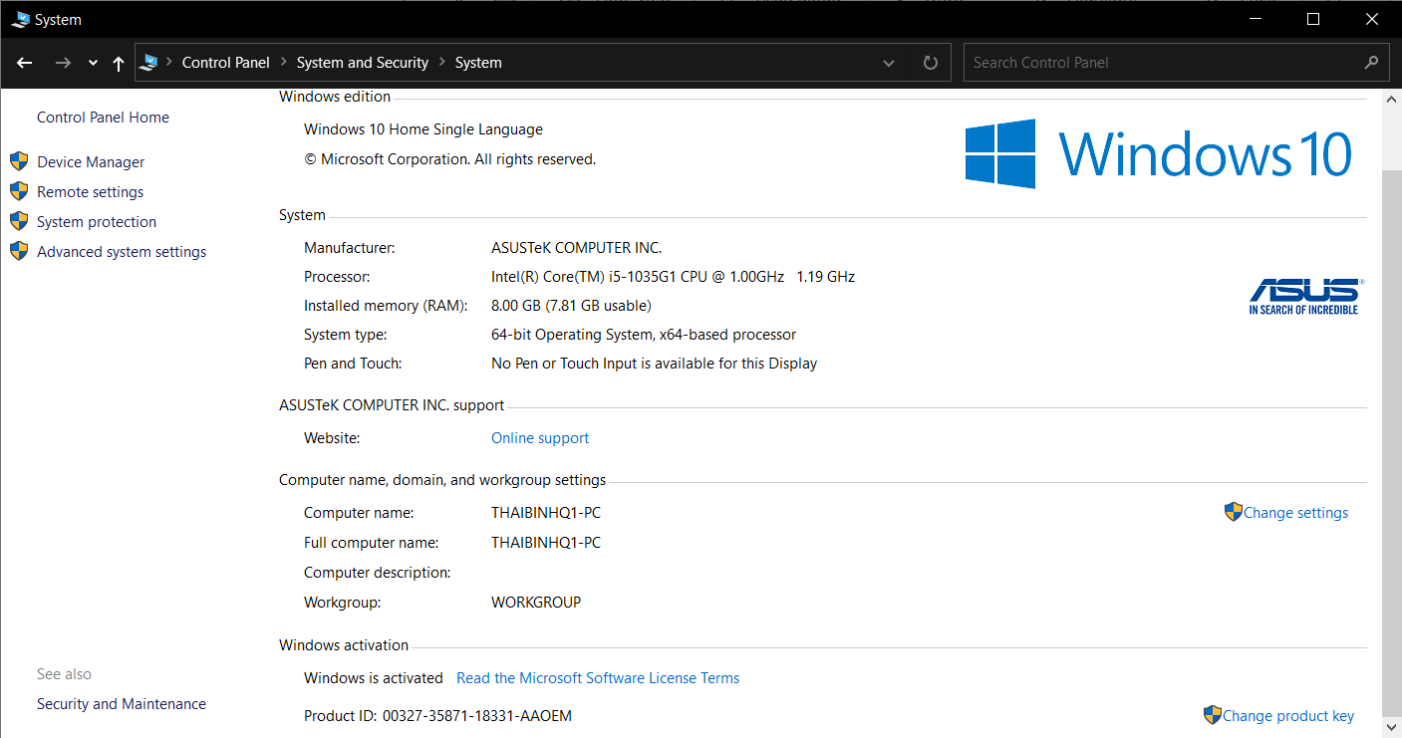
* Typing the username and password, press **Enter** key. 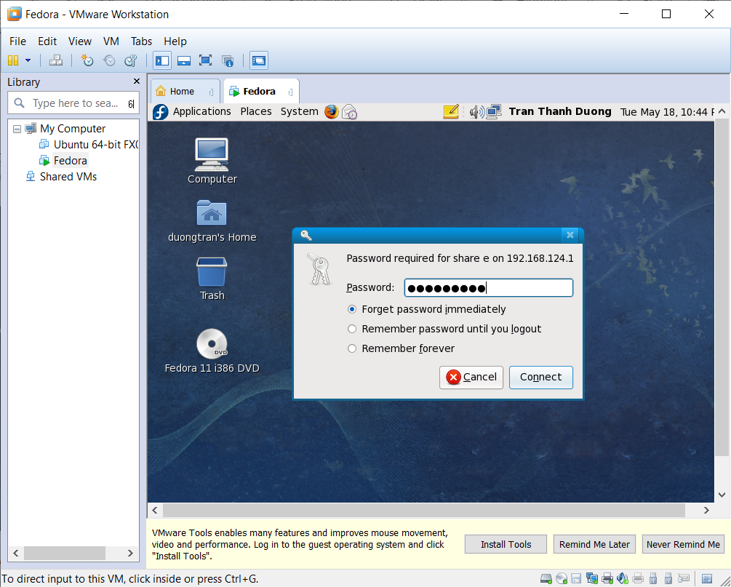
* The windows shared object is appeared.

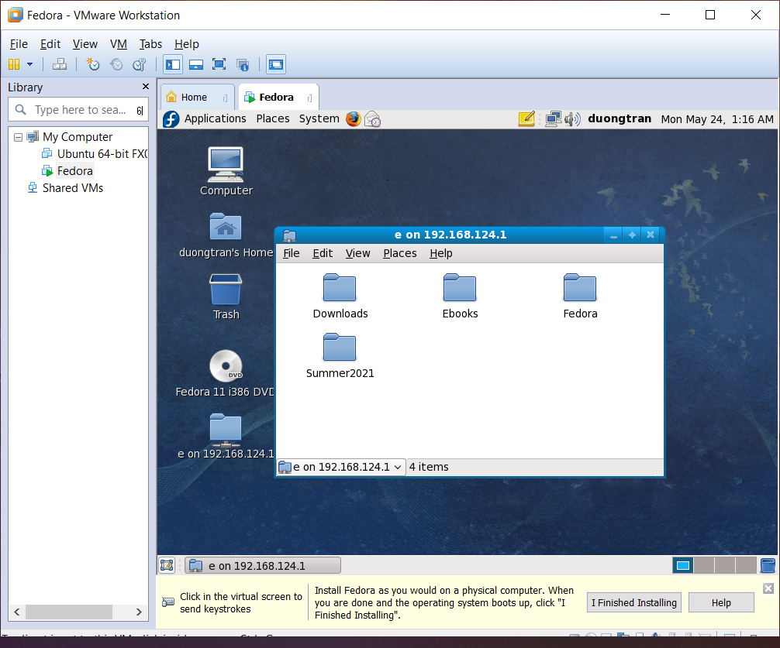

## **Using the command prompt of Fedora**

1. Choose the **“Application”** menu on the taskbar.
2. Choose **“System Tools”,** click the Terminal items.
3. Using some command as:

* mc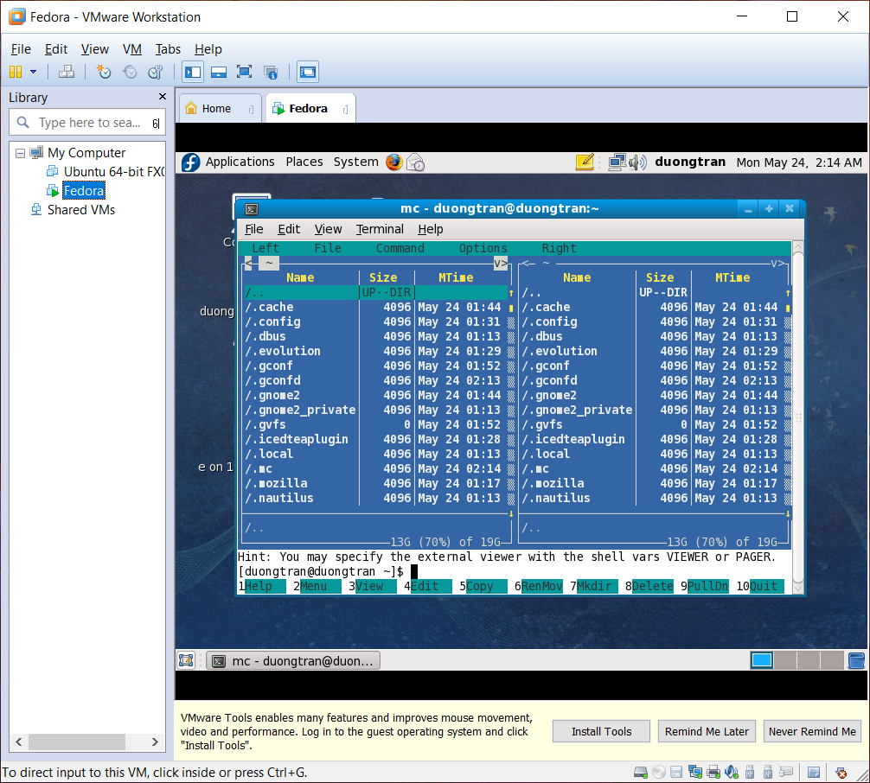

**F7 Function: using to create a new directory.**

* ifconfig
* 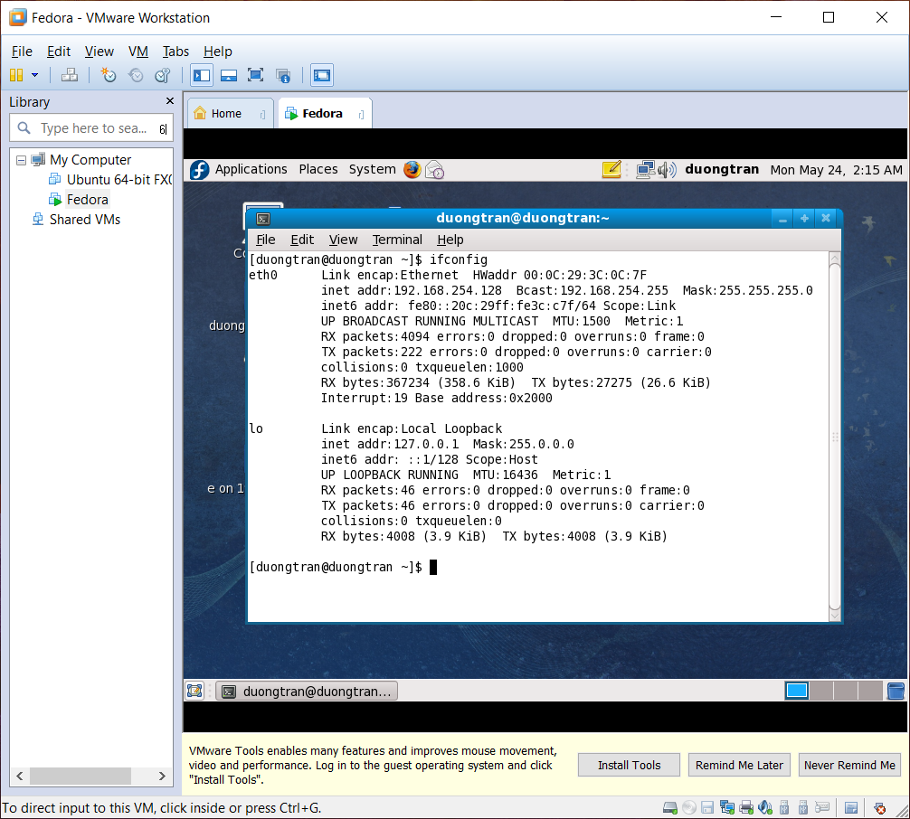

## **Use the compiler in C-C++ language in Linux with gcc**

* Syntax for C compiler: **gcc -o -filedestination filesource**
* Syntax for C++ compiler: **g++ -o filedestination filesource**

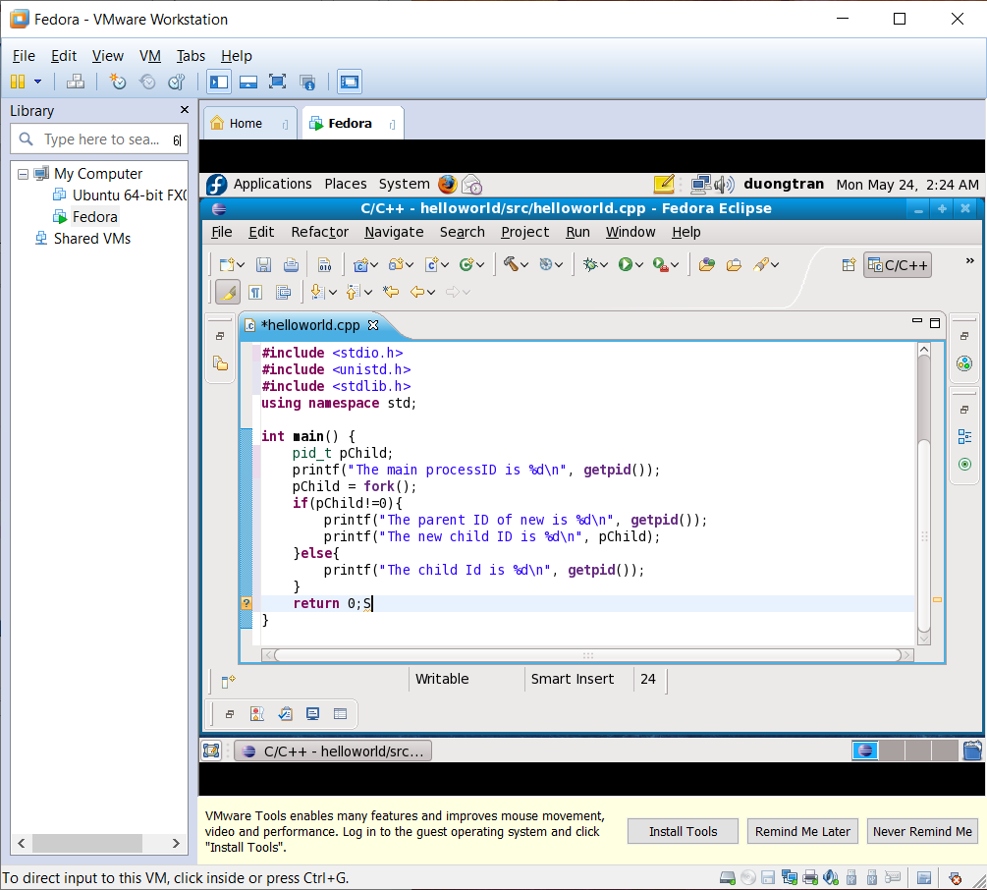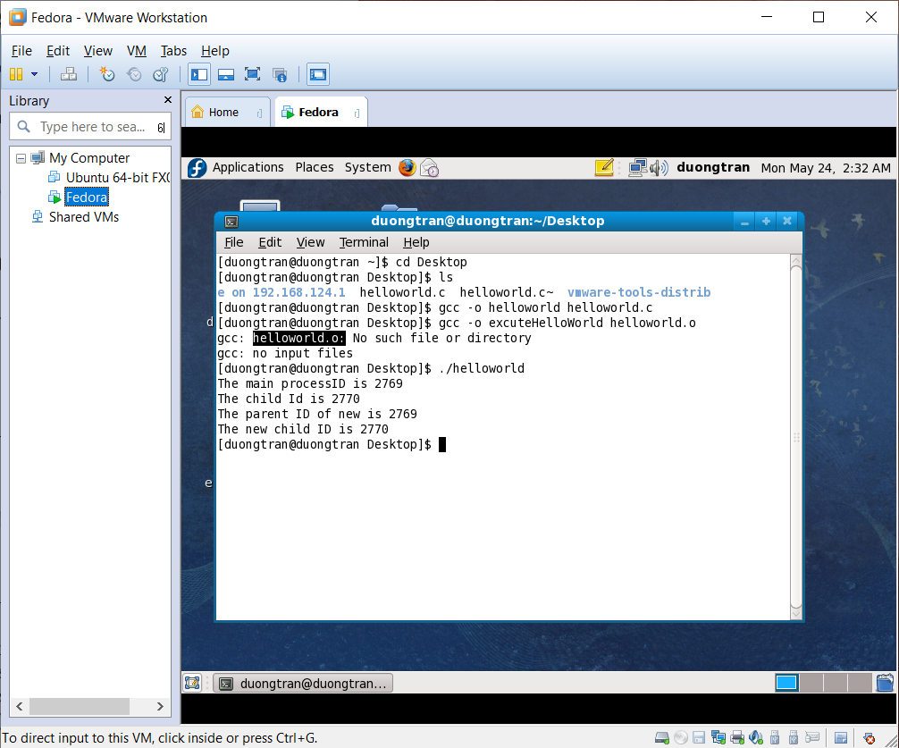

Explanation code: This sample code is using **fork(),** which is used to create a new process (or **child process**), which runs concurrently with the **parent process**. If **pChild = 0**, means the child process is running, **pChild != 0** means the parent process is running. The output result is both, so the child process and parent process are running concurrently.